Ready For Tomorrow

Project Recruitment - Job Description

The "Ready for Tomorrow" Program - An Educational Initiative for the Promotion of Ethiopian Youth in Israel
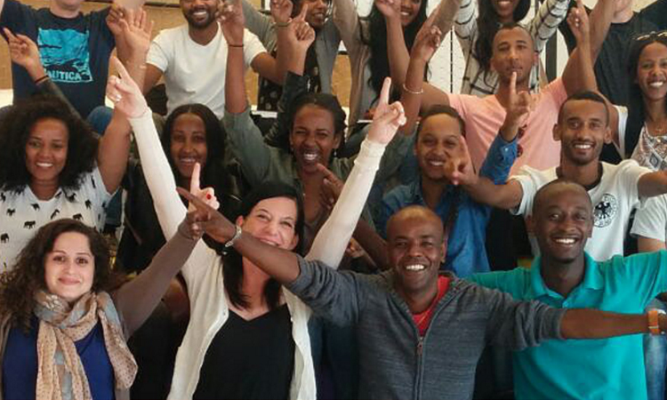
The overarching goal is to encourage young people from the Ethiopian community to go to higher education and improve their employment prospects in the medical and health professions. We seek to create opportunities for learning and development, create motivation, strengthen self-image, personal and community identity, and develop young leadership that will lead to social and image change in the community.

The project's description:
• Individual mentoring and reinforcement - by students and volunteers.
• Empowerment workshops – balancing heritage preservation and integration into Israeli society.
• Current affairs - engaging in issues on the public agenda and developing young leadership.
• Social Beit Midrash and development of mentoring skills.
• Seminars on professional subjects: medicine, technology and more.
• 3-2 tours per year in academic and health care institutions (hospitals, clinics, Magen David Adom stations and other medical facilities).
• Encourage high school students to volunteer at local clinics and health funds as part of their “personal commitment” school requirements (high school students are required to volunteer in the community)
• Meetings with inspiring people from the community and the general population.
• Involvement of parents in activities (3 compulsory sessions per year)
Job Description - Projector
Step 1:
• Negotiating and “closing” agreements (including facilities with authorities or organizations that are potential partners for the "Ready For Tomorrow" program.
• Management of student identification and screening processes (candidates)
• Formation of the group of students accepted into the program
• Building a syllabus for the program
• Recruiting volunteers, lecturers and practitioners
Step 2: Concentrate on the actual plan

• Tracking, escorting and guiding students
• Contact with students ’schools, teachers and staff
• Contact with student parents
• Content - tracking and aligning with goals and coordinating with lecturers and practitioners
• Logistics, Administration - Tours and visits to relevant organizations and budget management
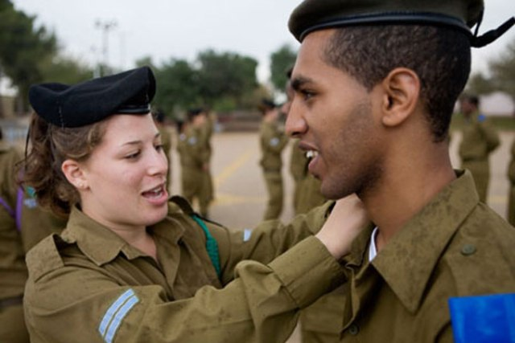
Job Requirements: Familiarity with the world of education and society (priority for graduate students), high organizational ability and performance, team work ability.

Scope of work - half-time with the possibility of full-time employment later

It is advisable to open the first cycle of the program:
September 2020 - Starting Pilot programs for "Ready for Tomorrow."

Those interested will contact Jaffa Elmo 052-2388764 aytegebmengistu@gmail.com

