Advertising and Promotion
Academic Syllabus
Summer: 2021
EBKN 315
Course Name: Advertising and Promotion

Course components: Lecture via Zoom

Students are expected to attend all classes throughout the semester and to arrive on time. Missed classes will require a short paper, to be assigned by the instructor. A third absence will result in an automatic penalty of one letter grade (an A will become a B). A fourth absence will result in the student being dropped from the course. Arriving late without cause is unacceptable, as it disrupts the flow of the class. A third late arrival will be counted as an absence, and subject to the above penalties.

Students with a learning disability or handicap should speak with the instructor or the school administration. Touro College, as a matter of policy, will attempt to accommodate learning disabilities or handicaps as best as possible without degrading the quality of the course. Students, however, must bring the disability or handicap to the instructor/administration’s attention at the beginning of the semester.

ACADEMIC INTEGRITY STATEMENT
Touro College and University System is a community of scholars and learners committed to maintaining the highest standards of personal integrity in all aspects of our professional and academic lives. Students and faculty are expected to share a mutual respect for teaching, learning and the development of knowledge. Because intellectual integrity is a hallmark of scholarly and scientific inquiry as well as a core value of the Jewish tradition on which our university system was founded, students and faculty are expected to adhere to the highest standards of honesty, fairness, professional conduct of academic work and respect for all community members.

Academic honesty supports our shared intellectual culture and our ability to trust one another. Students must avoid all acts of dishonesty, including, but not limited to:
- cheating
- plagiarizing (presenting the work or ideas of others as your own)
- fabricating (making up information, data, or research results)
- tampering (unauthorized removal or alteration of College documents, software, equipment, or other academic-related materials, including other students’ work)
- lying
- working with others when assignments or exams require individual work
- making unauthorized copies of copyrighted material
- facilitating or tolerating the dishonesty of others

Academic dishonesty lowers scholastic quality and adversely affects those who will eventually depend on the knowledge and integrity of our graduates. Failure to uphold the principles of academic integrity negatively impacts the reputation of Touro, the value of each and every degree awarded by the institution, and the future success of our graduates.

The Touro College and University System views violations of academic integrity with the utmost gravity. Such violations will lead to appropriate sanctions, from failure in coursework up to and including expulsion from the Touro College and University System. We commit ourselves to the shared vision of academic excellence that can only flourish in a climate of integrity.

CELL PHONES AND CUMPUTERS
Cell phones should either be turned off or switched to silent/vibrate so as not to disturb the class. Computers may be used to take class notes only.

Simply put, students are expected (read, required) to be attentive during class lectures and to participate in class discussions. Students are not to receive/read text messages during class, surf the internet or otherwise be distracted from class via their cell phones. The same applies with computers. Students may take notes on their computers, but the computer screen may NOT be of an internet site or other reading/photo materials.

Being physically present is not enough to count as attendant. Students caught perusing the net, email, text messages or any material not related to the class will be marked as absent.

Course Objective:
Advertising Management is about the strategic use of communication to attract and engage a range of consumers about a product or service. An integrated marketing campaign makes use of advertising, public relations, direct marketing, promotion, trades shows, etc. to get the message across and advance sales of a product or service.
This course will introduce students to the use of advertising and related media as part of an integrated marketing campaign, with the goal of selling a firm’s products or services to either a target audience or to a general audience. Students will come away with the necessary tools to manage an integrated advertising campaign in an effective manner, emphasizing results!

Course Description:
 | Topic
Session | Part I: The IMC Foundation | Text Chapter
1 | Integrated Marketing Communications | 1
1 | Brand Management | 2
2 | Buyer Behaviors | 3
2 | The IMC Planning Process | 4
 | Homework 1
 | Part II: IMC Advertising Tools
3 | Advertising Campaign Management | 5
 | Advertising Design | 6
4 | Traditional Media Channels | 7
 | Homework 2
 | Part III: Digital and Alternative Marketing
 | 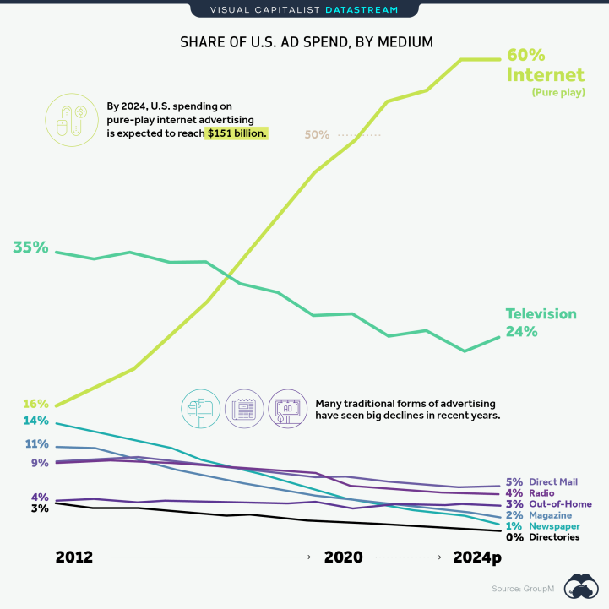
5 | Digital Marketing | 8
6 | Social Media | 9
7 | Alternative Marketing | 10
 | Homework 3
 | Part IV: IMC Promotional Tools
8 | Database and Direct Response Marketing and Personal Selling | 11
9 | Sales Promotions | 12
10 | Public Relations and Sponsorship Programs | 13
 | Homework 4
 | Part V: IMC Ethics, Regulation, and Evaluation
11 | Relations and Ethical Concerns | 14
12 | Evaluating an Integrated Marketing Program | 15
 | Homework 5

Evaluation criteria:

Home Work Assignments (50% of final grade): three will be five home assignments, each 33 questions (each question worth 3 points). Each assignment will cover two to or three lectures and their readings. You can download the home works from www.mdhcourses.com . Home works consist of a mix of multiple choice, True/False, and open questions. Home works represent 50% of your final grade. Home works are to be turned in electronically (by email). Home works will be returned to students after grading.

- All homework assignments are to be turned in word doc form only. No exceptions.
- All submissions are to have the student's name in the subject line of the file, along with the name of the course. Example: michealhumphries advertising hw1

All submissions that don't meet the above two rules will be penalized five points.

Semester Paper (50% of final grade): Integrated Marketing Communication involves coordinating a mix of tactics, combining to form a single strategy. The strategy must manage all of the messages delivered by all aspects of marketing communication so that they work together to present the brand in a coherent and consistent way. The Semester Paper will be an advertising campaign for a specific company: you can make up a company or use a real company. The campaign is to include an ad budget, target audience, ads and promotional materials.

This is a college semester project, not a high school book report. It is to be of professional quality. This means I will be grading for spelling, syntax, etc,, as well as appearance of the paper (i.e. graphics, pictures, etc.). All financials should be in table form.

Cover page of the semester project is to have your name and student number.

If you go to this link, you will have access to JStor and other sources for academic journals, etc.
https://www.jct.ac.il/%D7%A1%D7%98%D7%95%D7%93%D7%A0%D7%98%D7%99%D7%9D/%D7%A1%D7%A4%D7%A8%D7%99%D7%94/%D7%9E%D7%90%D7%92%D7%A8%D7%99-%D7%9E%D7%99%D7%93%D7%A2#db_0

Final Grade calculation:
50% for home work
50% for Semester Paper

Bibliography:

Text: Integrated Advertising, Promotion and Marketing Communications
Author: Kenneth E Clow and Donald Baack
Pearson Higher Education
ISBN 13: 9780134485003

The text can be obtained via the Pearson Higher Education web site: https://www.pearson.com/us/higher-education.html

