https://jobs.nrf.com/
https://nrffoundation.org/
The above two links will take you to the NRF's web site for both jobs posting and its RiseUP training and credential program. NRFis the US’s largest organization of retailers and is an important port of entry for a career in retail. Keep in mind that not all career positions in retail are on the retail store floor. Most are in the back office, and in management, marketing and finance positions. Students interested in being accepted for an internship at a major retail chain need to follow the above link and follow the procedures noted in the web site. For assistance, contact Mr. Humphries at humphires@bezeqint.net or 054-5316157.

Internships are for the summer. You need to apply during the fall semester to be accepted. So, research the internships that look interesting to you and start applying this fall.

IF YOU’RE SERIOUS ABOUT A RETAIL CAREER
If you are serious about internships and want to enhance your chances of obtaining one of them, I suggest you take the three courses offered by the National Retail Federation Foundation at https://nrffoundation.org/
The courses are RiseUP courses (see below) and located on the landing page: page down a little and you’ll see them. The courses are the retail industry’s standards for their respective topics. Completing these three courses shows potential employers that you are serious about a retail career and aren’t just taking a random shot at an internship.
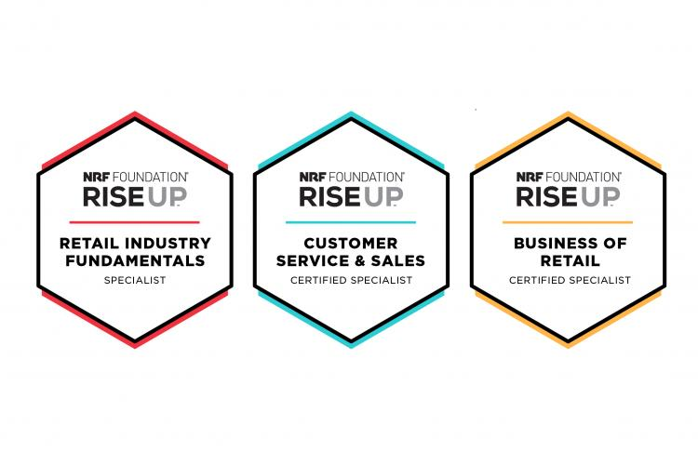
When you interview for a job, the interviewer is actually interested in how much you know about the industry: can you carry a conversation about the industry and its contemporary issues? Cramming for the interview a few days ahead of the interview won’t fool these people. Instead, if you want to be ahead of the game, sign up for their newsletter, SmartBrief, and keep up with events as they happen at https://nrf.com/. Read the blogs on the page, STORES Magazine, etc. You get the point.

