Micro Economics
Home Work 1
Chapters 1-5
PART I: INTRODUCTION TO ECONOMICS
Following are 40 multiple choice questions, each worth 2.5 points. Choose the answer you think most correct. If you are uncertain about an answer, write next to the question why you think your choice is correct.
Chapter 1 The Scope and Method of Economics
1) Which of the following is the best definition of economics?
A) the study of how individuals and societies choose to use the scarce resources that nature and previous generations have provided
B) the study of how consumers spend their income
C) the study of how business firms decide what inputs to hire and what outputs to produce
D) the study of how the federal government allocates tax dollars

2) Which of the following statements is not correct?
A) Economics is a behavioral science.
B) In large measure, economics is the study of how people make choices.
C) If poverty were eliminated, there would be no reason to study economics.
D) Economic analysis can be used to explain how both individuals and societies make decisions.

3) The study of economics
A) is a very narrow endeavor.
B) is a way of analyzing decision-making processes caused by scarcity.
C) is concerned with proving that capitalism is better than socialism.
D) focuses on how a business should function.

4) Which of the following is not one of the three fundamental concepts of economics?
A) profit maximization
B) marginalism
C) opportunity cost
D) the working of efficient markets

5) Suppose that you purchased a ticket to a jazz festival for $100 from an online ticket broker. Once you arrived at the festival, you discovered that parking costs you an additional $15. In this situation, the additional $15 you pay for parking is an example of
A) an economic loss.
B) opportunity cost.
C) marginal cost.
D) an inefficient cost.

6) You have decided that you want to attend a costume party as Iron Man. You estimate that it will cost $40 to assemble your costume. After spending $40 on the costume, you realize that the additional pieces you need will cost you $25 more. The marginal cost of completing the costume is
A) $15.
B) $25.
C) $40.
D) $65.

7) The concept of opportunity cost
A) is relevant only to economics.
B) can be applied to the analysis of any decision-making process.
C) applies to consumers but not to firms.
D) refers only to actual payments and incomes.

8) Opportunity cost is
A) that which we forgo, or give up, when we make a choice or a decision.
B) a cost that cannot be avoided, regardless of what is done in the future.
C) the additional cost of producing an additional unit of output.
D) the additional cost of buying an additional unit of a product.

9) The reason that opportunity costs arise is that
A) an economy relies on money to facilitate exchange of goods and services.
B) resources are scarce.
C) there are no alternative decisions that could be made.
D) people have limited wants.

10) Which of the following is not an opportunity cost of attending college?
A) the tuition you pay
B) the income you could have earned if you didn't attend college
C) the alternative uses of the time you spend studying
D) the cost of the food that you consume while you are attending college

Chapter 2 The Economic Problem: Scarcity and Choice

1) The process by which resources are transformed into useful forms is
A) capitalization.
B) consumption.
C) production.
D) allocation.

2) Outputs in the production process are
A) pollution.
B) money.
C) goods and services of value to households.
D) resources.

3) Which of the following is not a resource as the term is used by economists?
A) land
B) labor
C) buildings
D) money

4) Which of the following would an economist classify as capital?
A) a $50 bill
B) a corporate bond
C) a post office employee
D) a guitar used by a musician

5) Capital, as economists use the term
A) is the money the firm spends to hire resources.
B) is money the firm raises from selling stock.
C) refers to the process by which resources are transformed into useful forms.
D) refers to things that have already been produced that are in turn used to produce other goods and services.

6) The concept of opportunity cost is based on the principle of
A) need.
B) consumption.
C) scarcity.
D) profit.

7) The concept of trade-offs would become irrelevant if
A) we were dealing with a very simple, one-person economy.
B) poverty were eliminated.
C) scarcity were eliminated.
D) capital were eliminated.

8) Suppose you are deciding whether to spend your tax rebate check on a new iPod or a new digital camera. You are dealing with the concept of
A) equity.
B) comparative advantage.
C) opportunity costs.
D) the fallacy of composition.

9) According to the theory of comparative advantage, specialization and free trade will benefit
A) only that trading party that has both an absolute advantage and a comparative advantage in the production of all goods.
B) all trading parties, even when some are absolutely more efficient producers than others.
C) only that trading party that has an absolute advantage in the production of all goods.
D) only that trading party that has a comparative advantage in the production of all goods.

Refer to the information provided in Table 2.1 below to answer the following question(s).

Table 2.1
 | Krystal | Mark
Writing Poems | 8 | 12
Writing TV Commercials | 2 | 4

10) Refer to Table 2.1. For Krystal, the opportunity cost of writing one TV commercial is
A) 1/4 of a poem.
B) 2 poems.
C) 4 poems.
D) 6 poems.

Chapter 3 Demand, Supply, and Market Equilibrium

1) Michael Dell was the first individual who sold computers by mail order. The company founded by Dell is now one of the largest and most successful computer companies in the United States. Michael Dell would be classified as a(n)
A) entrepreneur.
B) opportunist.
C) monopolist.
D) socialist.

2) Firms are organizations that
A) take advantage of the public.
B) transform resources into products.
C) transform outputs into inputs.
D) demand consumer outputs.

3) Why do firms engage in the activity of production?
A) to help society advance technologically
B) to participate in the circular flow
C) to acquire profits
D) to develop a supply schedule

4) Mary Kay Ash was one of the first individuals who sold cosmetics directly to customers via independent sales representatives. The company founded by Mary Kay is now one of the largest and most successful cosmetics companies in the world. Mary Kay Ash would be classified as a(n)
A) entrepreneur.
B) opportunist.
C) monopolist.
D) socialist.

5) Organizations that transform resources into products are known as
A) firms.
B) entrepreneurs.
C) households.
D) factors.

6) The consuming units in an economy are known as
A) firms.
B) entrepreneurs.
C) households.
D) factors.

7) In input, or factor, markets
A) consumers purchase products.
B) firms supply goods.
C) households supply resources.
D) households demand goods.

8) A factor market is
A) where goods are exchanged.
B) where resources are exchanged.
C) where goods are made.
D) organized by government.

9) In an output market
A) consumers purchase products.
B) firms purchase resources.
C) households earn income.
D) land, labor, and capital may be exchanged.

10) Among the factors of production are
A) capital.
B) wages.
C) income.
D) all of the above.

Chapter 4 Demand and Supply Applications

1) In the short run, it is necessary to nonprice ration a good whenever ________ exists.
A) excess demand
B) excess supply
C) a surplus
D) market equilibrium

2) Among the methods of non-price rationing are
A) coupons.
B) favored customers.
C) waiting in line.
D) all of the above.

3) The price system
A) automatically distributes scarce goods.
B) is inefficient.
C) requires government help to allocate goods.
D) is the only way to allocate goods.

4) Attempts to bypass price rationing in the market
A) are efficient.
B) are easily administered.
C) are costly.
D) always fail.

5) Favored customers are customers who receive special treatment from dealers during periods of
A) excess demand.
B) excess supply.
C) price above equilibrium.
D) equilibrium.

Refer to the information provided in Figure 4.1 below to answer the questions 6 & 7 that follow.

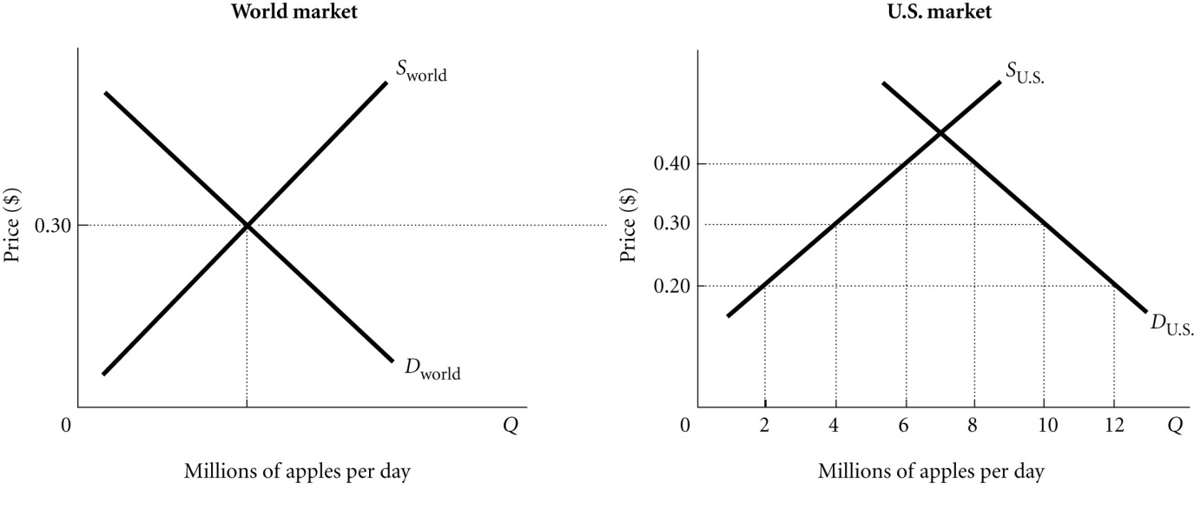
Figure 4.1

6) Refer to Figure 4.1. At the world price of 30 cents per apple the United States imports ________ million apples per day.
A) 2
B) 4
C) 6
D) 10
7) Refer to Figure 4.1. If a 10-cent-per-apple tax is levied on imported apples, the United States will
A) import 2 million apples per day.
B) import 4 million apples per day.
C) import 6 million apples per day.
D) import 8 million apples per day.

Refer to the information provided in Figure 4.2 below to answer the questions 8 & 9 that follow.

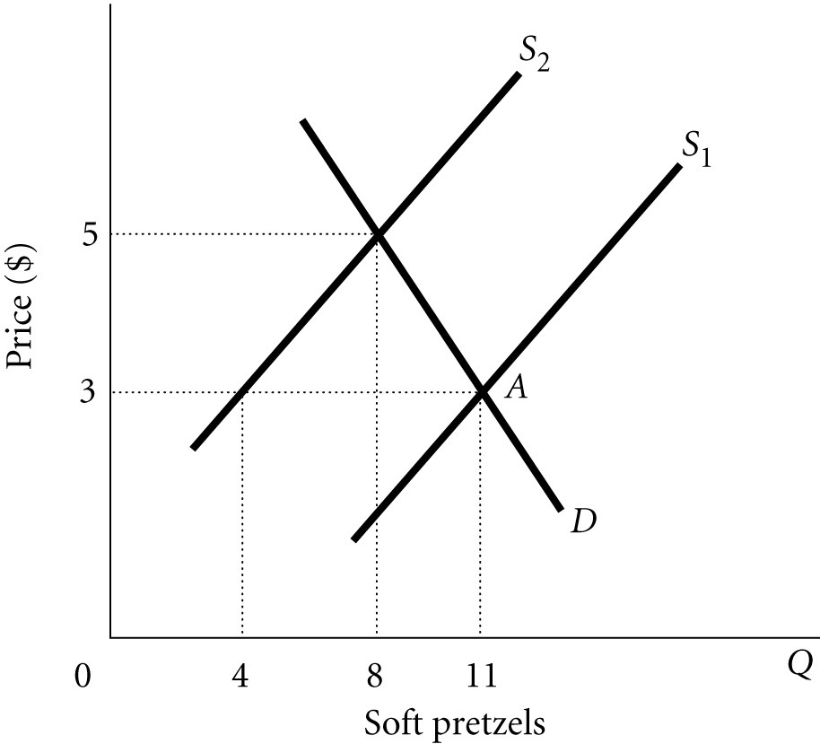
Figure 4.2

8) Refer to Figure 4.2. The market is initially in equilibrium at Point A and supply shifts from S1 to S2. Which of the following statements is true?
A) Price will still serve as a rationing device causing quantity supplied to rise from 8 to 11 soft pretzels.
B) There is no need for price to serve as a rationing device in this case because the new equilibrium quantity is higher than the original equilibrium quantity.
C) Price will still serve as a rationing device causing quantity demanded to fall from 11 to 8 soft pretzels.
D) The market cannot move to a new equilibrium until there is also a change in supply.

9) Refer to Figure 4.2. The market is initially in equilibrium at the intersection of S2 and D, and supply shifts from S2 to S1. Which of the following statements is true?
A) Price will still serve as a rationing device causing quantity demanded to rise from 8 to 11 soft pretzels.
B) There is no need for price to serve as a rationing device in this case because the new equilibrium quantity is lower than the original equilibrium quantity.
C) Price will still serve as a rationing device causing quantity supplied to fall from 8 to 4 soft pretzels.
D) The market cannot move to a new equilibrium until there is also a change in supply.

10) An example of an ineffective price ceiling would be the government setting the maximum price of wheat at ________ per bushel when the market price is at $5.00 per bushel.
A) $2.25
B) $3.00
C) $4.75
D) $6.00

Chapter 5 Elasticity

Refer to the information provided in Figure 5.1 below to answer the questions 1 & 2 that follow.

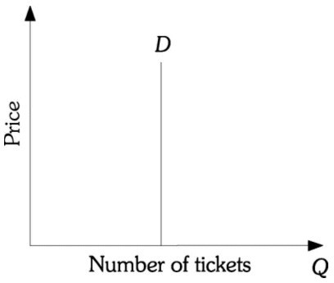
Figure 5.1

1) Refer to Figure 5.1. The demand for tickets is
A) perfectly price elastic.
B) perfectly price inelastic.
C) unit price elastic.
D) perfectly income inelastic.

2) Refer to Figure 5.1. The price elasticity of demand for tickets
A) is equal to zero.
B) is equal to 1.
C) is infinity.
D) varies at every point along the demand curve.
Answer: A

3) Demand determines price entirely when
A) demand is downward sloping.
B) demand is perfectly inelastic.
C) supply is perfectly inelastic.
D) supply is perfectly elastic.

4) A perfectly price elastic demand curve will be a ________ line.
A) horizontal
B) vertical
C) positively sloped
D) negatively sloped

5) When the price of coffee decreases 5%, quantity demanded increases 5%. The price elasticity of demand for coffee is ________ and total revenue from coffee sales will ________.
A) elastic; decrease
B) elastic; increase
C) inelastic; decrease
D) unit elastic; not change

6) The All Smiles Greeting Card Company wants to increase the quantity of greeting cards it sells by 20%. If the price elasticity of demand is -5.0, the company must
A) increase price by 4.0%.
B) decrease price by 4.0%.
C) increase price by 0.25%.
D) decrease price by 0.25%.

7) A government wants to reduce electricity consumption by 40%. The price elasticity of demand for electricity is -10. The government must ________ the price of electricity by ________.
A) raise; 4.0%
B) raise; 0.25%
C) raise; 1.25%
D) lower; 0.25%

8) A government wants to reduce electricity consumption by 10%. The price elasticity of demand for electricity is -0.1. The government must ________ the price of electricity by ________.
A) raise; 100.0%
B) raise; 10.0%
C) raise; 1.0%
D) lower; 20%

9) The price elasticity of demand for bottled water in New York is -3, and the price elasticity of demand for bottled water in Florida is -0.6. In other words, demand in New York is ________ and demand in Florida is ________.
A) elastic; inelastic
B) inelastic; elastic
C) elastic; unit elastic
D) inelastic; unit inelastic

10) An increase in quantity demanded caused no change in the equilibrium price. Thus, demand must be
A) perfectly inelastic.
B) inelastic.
C) elastic.
D) perfectly elastic.

